**Networking**

**Class IX**

**Lecture 21**

***(Network Fundamentals)***

**.**



# Lab Objectives:

* Short description on Network
* Different types of Network.
* Importance of network standard.
* Network components, Device & functions.

# Network

* A network is a group of two or more computer systems or other devices that are linked together to exchange data. Networks share resources, exchange files and electronic communications. For example, networked computers can share files or multiple computers on the network can share the same printer.
* In one sentence, a network is defined as a group of two or more computer systems linked together.

# Different types of Network

* There are many types of computer networks. Common types of networks include the following:
* Local-area network (LAN): The computers are geographically close together (that is, in the same building).
* Wide-area network (WAN): The computers are farther apart and are connected by telephone lines or radio waves.
* Metropolitan-area network (MAN): A data network designed for a town or city.
* Home-area network (HAN):  A network contained within a user's home that connects a person's digital devices.
* Virtual private network (VPN):  A network that is constructed by using public wires — usually the Internet — to connect to a private network, such as a company's internal network.
* Storage area network (SAN): A high-speed network of storage devices that also connects those storage devices with servers.

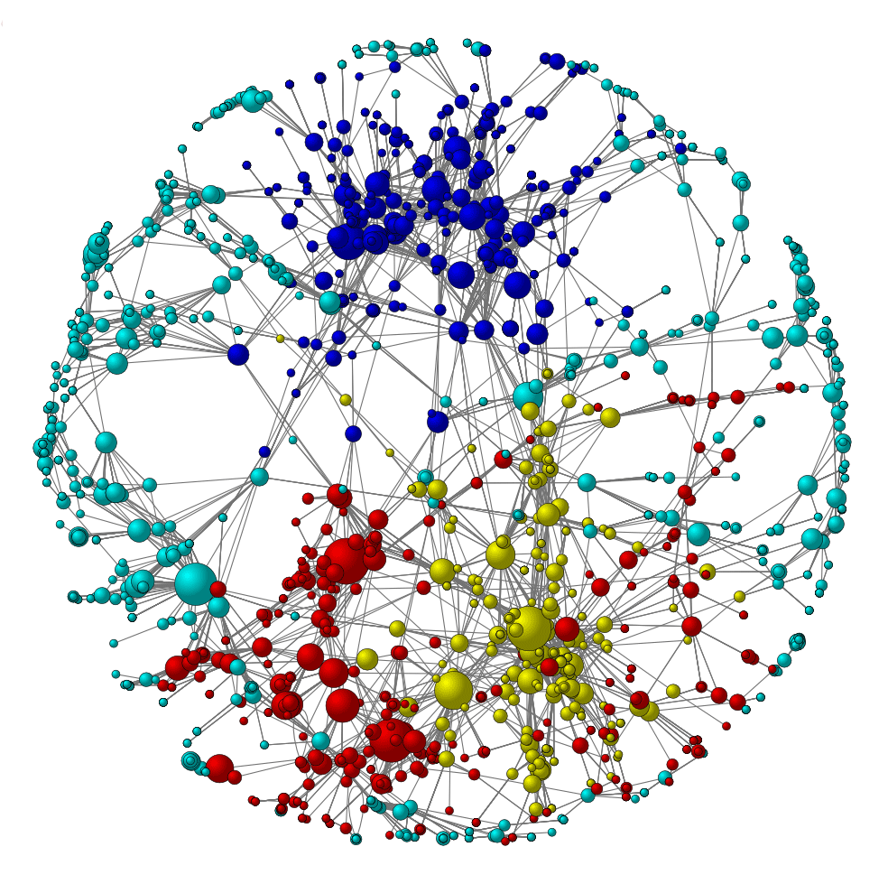

# Importance of Network standards

* Network standards are important to ensure that hardware and software can work together. Without standards you could not easily develop a network to share information. Networking standards can be categorized in one of two ways:  formal and de facto (informal).
* Formal standards are developed by industry organizations or governments. Formal standards exist for network layer software, data link layer, hardware and so on. Formal standardization is a lengthy process of developing the specification, identifying choices and industry acceptance.
* There are a several leading organizations for standardization including The International Organization for Standardization (ISO) and The American National Standards Institute
* (ANSI).  The most known standards organization in the world is the Internet Engineering Task Force (IETF). IETF sets the standards that govern how much of the Internet operates.
* The second category of networking standards is de facto standards. These standards typically emerge in the marketplace and are supported by technology vendors but have no official backing. For example, Microsoft Windows is a de facto standard, but is not formally recognized by any standards organization. It is simply widely recognized and accepted.

# Network components, device and functions

* Networks share common devices and functions, such as servers, transmission media (the cabling used to connect the network) clients, shared data (e.g. files and email), network cards, printers and other peripheral devices.
* The following is a brief introduction to common network components and devices. You can click any link below to read the full Wikipedia definition:
* [Server](https://www.webopedia.com/TERM/S/server.html):  A computer or device on a network that manages network resources. Servers are often dedicated, meaning that they perform no other tasks besides their server tasks.
* [Client](https://www.webopedia.com/TERM/C/client.html): A client is an application that runs on a personal computer or workstation and relies on a server to perform some operations.
* [Devices](https://www.webopedia.com/TERM/D/device.html): Computer devices, such as a CD-ROM drive or printer, that is not part of the essential computer. Examples of devices include disk drives, printers, and modems.
* [Transmission Media](https://www.webopedia.com/TERM/T/transmission_media.html): the type of physical system used to carry a communication signal from one system to another. Examples of transmission media include twisted-pair cable, coaxial cable, and fiber optic cable.
* [Network Operating System (NOS)](https://www.webopedia.com/TERM/N/network_operating_system_NOS.html): A network operating system includes special functions for connecting computers and devices into a local-area network (LAN). The term network operating system is generally reserved for software that enhances a basic operating system by adding networking features.
* [Operating System](https://www.webopedia.com/TERM/O/operating_system.html):  Operating systems provide a software platform on top of which other programs, called application programs, can run. Operating systems perform basic tasks, such as recognizing input from the keyboard, sending output to the display screen, keeping track of files and directories on the disk, and controlling peripheral devices such as disk drives and printers
* [Network Interface Card (NIC)](https://www.webopedia.com/TERM/N/network_interface_card_NIC.html):  An expansion board you insert into a computer so the computer can be connected to a network. Most NICs are designed for a particular type of network, protocol, and media, although some can serve multiple networks.
* [Hub](https://www.webopedia.com/TERM/H/hub.html): A common connection point for devices in a network. A hub contains multiple ports. When a packet arrives at one port, it is copied to the other ports so that all segments of the LAN can see all packets.
* [Switch](https://www.webopedia.com/TERM/S/switch.html): A device that filters and forwards packets between LAN segments. Switches operate at the data link layer (layer 2) and sometimes the network layer (layer 3) of the OSI Reference Model.
* [Router:](https://www.webopedia.com/TERM/R/router.html) A router is a device that forwards data packets along networks. A router is connected to at least two networks and is located at gateways, the places where two or more networks connect.
* [Gateway](https://www.webopedia.com/TERM/G/gateway.html): A node on a network that serves as an entrance to another network.
* [Bridge](https://www.webopedia.com/TERM/B/bridge.html): A device that connects two local-area networks (LANs), or two segments of the same LAN that use the same protocol
* [Channel Service Unit/Digital Service Unit (CSU/DSU)](https://www.webopedia.com/TERM/C/CSU_DSU.html): The CSU is a device that connects a terminal to a digital line. Typically, the two devices are packaged as a single unit.
* [Terminal Adapter](https://www.webopedia.com/TERM/T/terminal_adapter.html): (ISDN Adapter): A device that connects a computer to an external digital communications line, such as an ISDN line. A terminal adapter is a bit like a modem but only needs to pass along digital signals.
* [Access Point](https://www.webopedia.com/TERM/A/AP.html): A hardware device or a computer's software that acts as a communication hub for users of a wireless device to connect to a wired LAN.
* [Modem](https://www.webopedia.com/TERM/M/modem.html): (modulator-demodulator): A modem is a device or program that enables a computer to transmit data over, for example, telephone or cable lines.
* [Firewall](https://www.webopedia.com/TERM/F/firewall.html):  A system designed to prevent unauthorized access to or from a private network. Firewalls can be implemented in both hardware and software, or a combination of both.
* [MAC Address](https://www.webopedia.com/TERM/M/MAC_address.html): A MAC (Media Access Control) address, sometimes referred to as a hardware address or physical address is an ID code that's assigned to a network adapter or any device with built-in networking capability.



***Thank you***